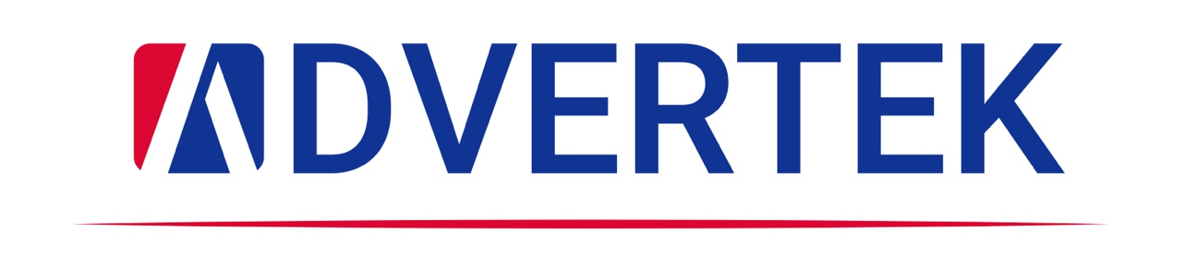
Press Release
March 9th, 2024
Advertek Announces Strategic Acquisition of Custom Colour Imaging
VAUGHAN, ONT – Advertek Inc, one of Canada’s leading print innovators, announce the strategic acquisition of Custom Colour Imaging (CCI), a Toronto-based photo lab and print-on-demand company with more than 50 years of heritage and expertise. Terms were not disclosed.
This acquisition marks a significant milestone in Advertek's 25-year journey as a leader in commercial printing and photo imaging. Advertek, renowned for its excellence in various printing techniques such as Lithography, digital printing, wide format, dye sublimation, and the production of promotional items, is poised to enhance its service offerings through this acquisition of a premium photo lab and print on demand.
"This strategic move not only broadens our technological horizons but also significantly boosts our capacity to provide personalized and embellished products,” says Joe Montalbano, Co-CEO of Advertek. “This strategic move not only diversifies Advertek's portfolio but also promises to deliver increased value and innovative solutions to its clients all across North America.”
“Integrating CCI’s specialized skills distinctly positions us to offer bespoke, high-quality printed products, further distinguishing our services in the market,” added Simon Spina, Co-CEO, of Advertek. “Advertek is set to expand its capabilities and reinforce its position at the forefront of the printing industry.”
For five decades, CCI carved out a niche as a specialist in print-on-demand services, particularly known for high-quality layflat photo books and premium canvas prints. The company employs top-of-the-line equipment like the HP Indigo presses, ensuring exceptional printing quality. Known for its advanced embellishment and engraving techniques, Custom Colour Imaging uses state-of-the-art technology such as the MGI Jet Varnish and Epilog Engraving Laser to add detailed finishes and intricate details to its products, setting a high standard in the industry.
Further, Custom Colour Imaging also produces board books and albums, using advanced bindery capabilities such as Smyth sewing and superior case-making abilities. Other book options include oversize books and sublimation and acrylic panels covers.

With its in-house woodworking shop dedicated to frame cutting and manufacturing, along with automated machinery for precise canvas stretching, CCI introduces an exceptional level of craftsmanship and meticulous attention to detail. This addition not only enhances the product range but also elevates the overall quality of Advertek's offerings.
Advertek's comprehensive expertise in various printing technologies pairs seamlessly with Custom Colour Imagings' focus on premium canvas printing and photo books. The merger of Advertek and Custom Colour Imaging forms a robust presence in the printing industry, offering clients an enriched array of services. This acquisition reaffirms both companies' dedication to providing exceptional quality and innovative printing solutions, catering to a diverse range of industry needs.
For media inquiries or further information, please contact:
Andy Montalbano
Co-COO
amontalbano@advertekprinting.com
416-459-6000

About Advertek:
Advertek, renowned in the printing industry, offers a wide array of services such as Lithography and digital printing, wide format, dye sublimation, and promotional items. Known for its commitment to innovation and quality, Advertek has established itself as a go-to partner for businesses in need of advanced and reliable printing solutions.
About Custom Colour Imaging:
Custom Colour Imaging excels in creating high-quality photo books, including lay flat books, as well as in premium canvas and silver halide printing. Renowned for their commitment to craftsmanship and meticulous attention to detail, they have become a preferred choice for both individuals and businesses seeking superior printing services. Their offerings are distinguished by personalized embellishments and precision engraving, cementing their reputation as a provider of top-tier printing solutions.

