AI in the photo industry: what to expect in 2024
This year has been incredibly fruitful for AI-based solutions, making an impact on how the general public and photographers, from beginners to professionals, utilize them. In this article, you will discover how AI is set to affect the photography industry in the coming year.
Technologies have become deeply rooted in our lives over the past year. The continuous growth of AI is tightly connected with technological advancements and widespread accessibility for the general public. Nearly any individual can now generate an image with a simple text prompt, without the need to spend time finding a location for a shot. This effortlessness of the image-creating or editing process raised concerns among photographers. Responding to these concerns, some organizations are trying to bring transparency to the field, while others further advance those technologies, significantly influencing the industry. What will it lead to in the upcoming year? Let’s find out.
What the big players did
In the spring of 2023, Adobe introduced Firefly. This model enables photographers of all levels to create quality visuals using text prompts. Integrated into Adobe Photoshop, Firefly extended the capabilities of generative AI to millions of software users, offering them the tools right within their familiar workspace.
This year, Getty Images came up with a new AI tool called Generative AI (GenAI), allowing users to generate photos based on prompts. Unlike other Generative AI engines, the Getty Images' tool utilizes their extensive library of photos instead of open-source materials. Importantly, photographers are compensated when their work serves as inspiration for an AI-generated image.
Meanwhile, Midjourney advanced its GenAI technologies with the introduction of the 5.2 model, released mid-year. This update allowed users to enjoy more detailed and high-quality images with improved colors, composition, and contrast. Concurrently, OpenAI unveiled the DALL-E 3 text-to-image model.
These moves by major players unequivocally signal the ongoing integration of AI in the photography industry.
Impact on the photography industry
The widespread accessibility of the above-mentioned and other image-generative tools resulted in an explosion of AI-generated images, strengthened by the power of social media platforms. It naturally raised concerns within communities about the transparency and ethics of such imagery, particularly for fields like photojournalism, where the authenticity of images is pivotal.
MIT's Computer Science and Artificial Intelligence Laboratory (CSAIL) researchers aimed to address this issue with "PhotoGuard," an AI tool designed to mitigate unauthorized image manipulations facilitated by AI generative tools. However, such solutions still have room for development. Training a defensive algorithm necessitates access to the generative model. Attackers attempting to modify images have ample time and tools, while the image itself can only rely on alterations made before publication without the capability to actively defend itself.
On the other hand, AI might significantly enhance and simplify the editing process, as it surpasses human retouchers in several ways. AI can tirelessly retouch without fatigue, maintains effectiveness during repetitive tasks, and does not require vacations. This makes AI a perfect tool for photographers who want to streamline their creative processes by delegating repetitive work like smoothing skin texture or removing minor imperfections.
Implications for photographers and creators
The question of whether or not to use AI for photography purposes is not topical. AI is here, whether you like it or not. The differentiation point is who and why are going to use it. For example, creative individuals who are building a personal brand may opt for over-editing to align with their vision, using appropriate editing tools. Professional photographers, on the other hand, might want to focus on preserving skin texture and natural tones while making subtle adjustments for loads of pictures. In the broader photography landscape, there is no one-size-fits-all movement, as different photographers have diverse objectives, from capturing a natural reportage shot to creating dramatically transformed images.
AI serves as a versatile tool that can either provide close-to-realism minor edits or transform photos into artistic interpretations, all dependent on the photographer's or retoucher’s unique vision.
What’s next for AI in photography?
Undoubtedly, AI will continue to significantly influence the photo industry. However, human creativity remains crucial as it shapes the retouching process. In 2024, the real power of retouching, whether for everyday users on smartphones for Instagram or experienced photographers for advertising, will emerge from the synergy of AI and human creativity. Personally, I am proud to play an active role in this evolution by developing AI-based software solutions for photographers and retouchers.
Oleg Sharonov, Founder and Board Member of Retouch4me and 3D LUT Creator (RELU OÜ)
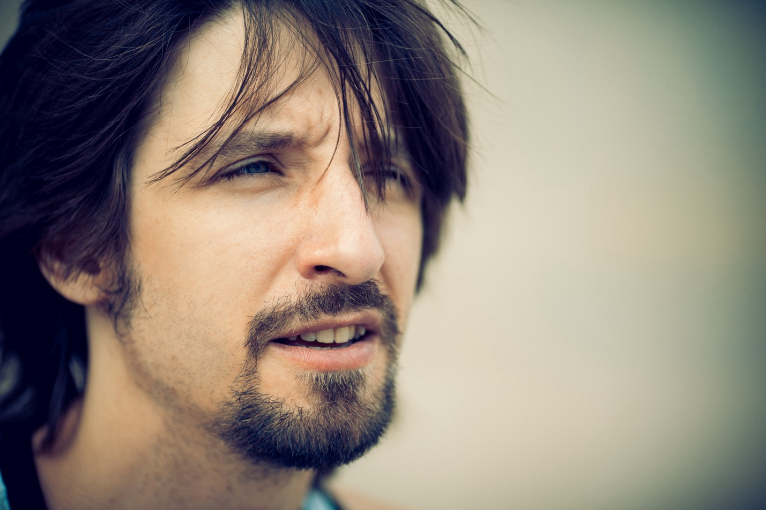
Instagram LinkedIn

